Angioma Alliance Walk Guide:

Angioma Alliance
520 W 21st St STE G2-411
Norfolk, VA 23517

www.Angioma.org
FB.com/AngiomaAlliance

Director of Resource Development
Stephanie Alband
salband@angioma.org
442-615-9221

Contents
GETTING ORGANIZED 5
Scheduling 5
State Charity Registration 5
Insurance 5
Flyer 6
EVENT COMMITTEE 7
Form a Committee 7
Committee Communications 7
Committee Education 7
BUDGET 8
FUNDRAISING 9
Pre-Event Fundraising 9
Day-of Fundraising 11
PUBLICITY 12
Honoree 12
Trademark of Because Brains Shouldn’t Bleed® 12
Open a Facebook Page 12
Twitter 12
Newspaper 12
Radio 13
Television 13
Online 13
Schools, Churches, and Workplaces 13
REGISTRATION 14
Online with Crowdrise 14
Registration Events 14
INCOME 15
Online Fundraising 15
Checks and Cash 15
Square Credit Card Transactions 15
EXPENSES 16
DAY-OF LOGISTICS 17
Registration 17
Angioma Alliance Table 17
Parking Assistance 17
Photography 17
Signs/Banners 18
Sound System 18
Tables and Chairs 18
Water Stations 18
Volunteer Thank You Gifts 18
AFTER THE EVENT 19
Account for and Submit Funds 19
Thank Your Volunteers, Sponsors, Donors, and Participants 19
Follow-up with Individuals or Businesses Who Offered Future Help 19
Write Down What Worked and What Didn’t 19
Take a Break! 19
THANK YOU! 19
APPENDIX: TEMPLATES 20
Sample Venue Solicitation Letter 21
Sample Sponsor Solicitation Letter 22
Sample Sponsorship Opportunities 23
Sample Sponsorship Commitment Form 24
Sample Inkind Donation Form 25
Sample Friends and Family Letter 26
Sample Press Release 27
Offline Donation Form 29
Expense Summary 30
Income Summary 31
Gift In Kind Worksheet 31
Pre-Event Income Worksheet 31
Day-of Income Worksheet 31
Activities/Raffles/Silent Auction Worksheet 31

Welcome!

Dear Friend in the Fight Against Cavernous Angioma,
Thank you for your interest in holding a walk in your community to sustain our mission to inform, support, and empower individuals affected by cerebral cavernous angioma (CCM) and drive research for a cure. It is only with friends like you that we can continue to expand our mission!
Team Angioma Alliance Walks are community-organized walks to raise awareness and funds for Angioma Alliance. You have taken the first and most difficult step: deciding to do it! A walk in your community will allow you to honor a special someone who is affected by CCM, and allow their friends and family an opportunity to show support for their journey. This packet is a resource and can be used to ensure that your walk will be a success its first year and grow every year after that!
This guide will serve as a toolkit for you to successfully plan your event, raise funds and awareness, and have fun! And remember, we are here to ensure you are successful, so please reach out when you are ready to start planning. We suggest allowing 4-5 months planning time. Also, we can help you recruit additional committee members and promote the event through social media and our website.
Whether your first walk is a home-run or humble and grassroots, it will grow and so will your supporters who can help with donating money, time and resources!
Collectively, our efforts result in a nationwide community bound together by CCM, but we don’t let our diagnosis define us - it only empowers us.
Warmest Regards,
Stephanie Alband
Development Director
Angioma Alliance
salband@angioma.org

GETTING ORGANIZED
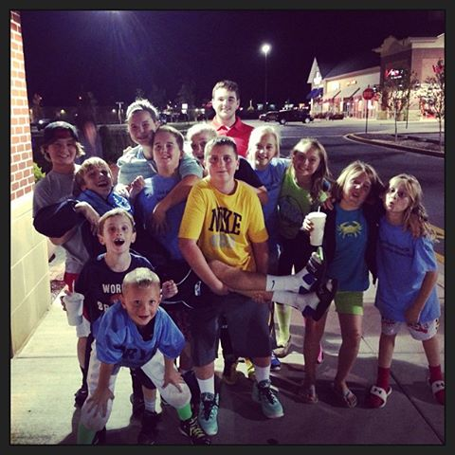

Scheduling
The first step in planning your walk is to secure a date and venue. Walks can be held anywhere and anytime of the year! Venues may include parks, malls, schools, YMCA camps or private property. Use your connections and be creative to ensure an attractive and cost efficient venue. There are local and state requirements that may apply to your event. Please read this section carefully.
Here are a few tips to remember when securing a date and venue:
- How much does the venue cost? If it’s more than $500, you may want to look at other options. Most municipal parks charge $200 - $500 for a permit. Some may offer a discounted rate or waive it for nonprofits.
- Is there a security deposit required? How much?
- Does the venue have adequate bathrooms? ADA Compliant? Enough parking? Shade? Shelter?
- Will the venue allow amplified music? Emcee? Pre-packaged or packaged food?
- Check community calendars to ensure no other conflicting events occur on the same day.
- How accurate is Google Maps in getting your participants to the location?
- Size of the location in proportion to the size of your event – picking a place that is far too big can be a problem, too.
- Do you have exclusive use or will you be sharing with the public or with other events?
- How many hours do you expect to use it, including set-up and clean-up?
- Will the venue be suitable for your add-ons, e.g., night walk, color run, zombie run?
- Once you have negotiated the contract, requirements and fees, and are ready to have the contract signed, please send to salband@angioma.org. All contracts must be in the name of Angioma Alliance and be signed by Angioma Alliance CEO, Connie Lee. This is to ensure you are not liable for any damage or incidents that occur.
The Appendix of this guide includes a template letter for soliciting venues. Once your venue and date are confirmed, email salband@angioma.org to help with promotion of the event.

State Charity Registration
Thirty-nine states require a non-profit to register before engaging in fundraising activities. Angioma Alliance is registered in states where we have had previous events, but may not be registered in your state. Please give us at least 6 weeks’ notice before your event so we can file the appropriate registration application.

Insurance
All venues will require liability insurance in case of damage or injury during your event. Angioma Alliance’s general liability policy will cover any insurance needs, but we’ll need to ask our insurance company for a new declaration page listing the venue as “co-insured”. Once you have the venue insurance requirements, please send them to salband@angioma.org. We will need the name and address of the event, the date of the event, and the expected number of attendees.

Flyer
A sample flyer is provided on the website here. You can use this flyer as a template and edit the fields to customize, or if you have someone who can donate their graphic design skills, even better! When you have your venue, date and time please reach out to salband@angioma.org to receive your event link through Crowdrise. See the Registration section of this document for more information on Crowdrise and important questions you will need to answer about your event before an event link is created. You will send this link out to have participants register and fundraise online.
You will continue to add to the flyer with entertainment, sponsors, and exciting details as you continue planning. If you need help creating your flyer please reach out to salband@angioma.org. Also, if you create your own please contact Stephanie so we can help publicize your walk.
The flyer should include the following, some of these items are obvious, others less so.
- The name of the Walk, Angioma Alliance Walk Honoring [YOUR HONOREE].
- Angioma Alliance logo
- Date, time, address of event
- Picture of Honoree (who you are walking for) and name
- Link to register
- Cost to register
- Entertainment and highlights of event
- Sponsor logos
- Angioma Alliance tax id #02-0600697
- This statement about Angioma Alliance, “This walk benefits Angioma Alliance, a 501c3 organization, dedicated to people affected by cavernous angiomas and their loved ones, health professionals, and researchers. Because Brains Shouldn’t Bleed®.”
- This statement about Cavernous Angioma, “Cavernous angiomas are mulberry-shaped leaky blood vessels in the brain and spinal cord. Cavernous angiomas can hemorrhage causing devastating effects including stroke, seizure, paralysis and death. 1 in 500 people have at least one cavernous angioma and many of these patients have multiple lesions. The only known treatment for cavernous angiomas is brain or spinal cord surgery, but this isn’t an option for everyone. For more information go to www.angioma.org.
- Your contact information

EVENT COMMITTEE

Form a Committee
While you are securing your date and venue you can begin to secure a committee. You can’t organize a walk without a great deal of help from a core group of people and additional help from others. Your committee should consist of a number of subcommittees with different areas of responsibility. The subcommittees can include just a co-chair or, ideally, a number of individuals with a co-chair leading the subcommittee. All committee members should work on every part of the walk, but it is important to have subcommittee Co-Chairs for accountability. Subcommittees should include:
- Fundraising (includes sponsorships, team participation, day-of fundraising, wrap events)
- Logistics (includes day-of permits, entertainment, vendors, chairs, tables, tents, etc.)
- Volunteers (includes day-of volunteer needs and pre-event needs)
- Day-of Registration (includes accounting and registration for day-of)
- PR/Marketing (includes publicizing on social media, community calendars, and pitching media local “why I walk” stories)
Consider who you can ask. Good choices include friends and family with the following types of experience or connections:

- Event planning
- Publicity/connection to news outlets
- Graphic design and marketing items
- Local government (for venue, permits, and publicity)
- Sales
- Small retail business owners/Chamber of Commerce members
- Entertainment connections
- Bookkeeping
- Connections to volunteer organizations – Rotary, Key Clubs, etc. who could help on the day of the event
- Connections to local philanthropic and/or family foundations

Committee Communications
Decide how your committee will communicate. There should be at least a couple of in-person meetings. A meeting can be held at someone’s home and include food, adult beverages, etc. to keep it fun. You can also communicate via email, Facebook group marked closed or secret, group text, and/or create a google doc.

Committee Education
Each committee member should be given a copy of this guide.

BUDGET
It is critical to establish a conservative budget for your event. It wouldn’t make sense to put a great deal of effort into an event only to have it lose money. Donors just like you look at our “cost to raise a dollar” to ensure that the most amount of money is spent on the mission of Angioma Alliance. A general rule to follow is that 25% of your fundraising goal can be spent on expenses. Your first walk, by its definition, may appear humble and grassroots, but it will grow and so will your supporters who can help with donating money, time and resources!
Below is a realistic first-year walk budget.

Revenue:
Sponsorships/Grants/Vendors $5,000
Participant Registration $750
Participant Peer-to-Peer Fundraising $5,000
Wrap Events/T-shirt Sales $750
Day-of Fundraising $1,000
Total Revenue $12,500

NET REVENUE: $11,500
Cost to Raise a Dollar = $.12
Thumbs Up! This falls within acceptable fundraising guidelines!

Expenses:
Venue Permit/Facility Rental $500
Printing Flyers/Signage/Misc. Supplies $200
T-Shirts $300
Rentals/Tables/Chairs/Stage/A/V $350
(if not donated)
Food/Utensils/Misc. Event Expenses $100
(if not donated)

Total Expenses $1,450

Expenses to consider when you’re budgeting:

- Venue charges
- City charges - permits, police, rescue squad if required
- Printing expenses for flyers, banners
- T-shirts
- Food/beverage
- Raffle tickets
- Thank you gifts for volunteers
- Planning meeting expenses
- Pre-walk breakfast, cocktails, or dinner with potential major donors
- Rentals – tables/chairs, sound equipment, activities
- Activities like bounce houses, a DJ, laser tag

FUNDRAISING
Fundraising should be your committee’s top priority! The main goal of the Walk is to raise funds first, and in doing so, you will raise awareness. Income can be generated in many ways, but most funds are raised before the event takes place! Your entire committee will each devote some time to fundraising. Whether it’s recruiting family and friends, soliciting their work for a corporate sponsorship or securing in-kind donations for the silent auction, everyone on the committee should raise funds in some way. As mentioned in the budget section, most funds are raised by corporate sponsors and by your friends and family fundraising themselves.
The logistics of how the money is collected is discussed in more detail under the income and registration section. Below outlines how to raise funds before the walk and on the day-of.

Pre-Event Fundraising
- Sponsorships – this can be the largest source of income for your event. Sponsors can have their names on t-shirts, banners, and awards. Sponsorships can range from $250 - $10,000. It may be difficult to gain sponsorships the first year of an event, but if you have a good turnout the first year, you should be able to add many sponsors the second year. Examples of sponsors can include your employer, your bank, the businesses you solicit and local companies with a significant presence in the community. See the sample sponsorship benefits in the Appendix.
To solicit a business:
- Call ahead to learn manager or owner’s name and schedule.
- Visit with all of your information in hand including a solicitation letter, an event flyer with a picture of the affected person, a sponsorship form with your contact info, and a copy of the 501c3 letter.
- Some businesses may offer a sponsorship immediately. Others may require some time to decide. If you get an immediate decision, please get a business card and the form.
- The business can also send you a digital logo for use on t-shirts and banners. Logos must be received well in advance of printing deadlines.
- If the business doesn’t contact you within 2-3 weeks, follow up with a phone call directly to the manager. You will probably have to follow up 3-4 times - this is normal.
- If a business will not sponsor, ask them for a gift certificate for the auction/raffle or ask them to underwrite a cost for the day-of, like providing water or bagels for participants. Also, ask them “how and when should I ask for your company’s support next year?”

- Participant Peer-to-Peer Fundraising – this is also a large source of income for your event. Angioma Alliance uses Crowdrise for registration and peer-to-peer fundraising. Your event will have its own event webpage. Participants will go to the event webpage on Crowdrise, where they will create their own fundraising webpage with their story of why they are participating. They will also register their team name and invite their friends and families to join them at the walk and to fundraise themselves. This is a crucial part of the success of the event. Telling your story and inviting everyone to join you is so important! Every committee member will register for the event and ask their friends and family to donate, register and fundraise. There is a sample friends and family ask letter in the appendix.

- Registration fees – you can have a registration fee if you like. Some suggest that not having a registration fee encourages participants to fundraise beyond the amount of a registration fee. If you do have a registration fee ensure that it covers, at minimum, all event expenses (but doesn’t include t-shirts) so any additional income becomes proceeds. Registration is typically $25-$50, depending on the location.

- Grants - A walk is a good time to look for grant opportunities. Some of our organizers have obtained $1000-$5000 in local grants at the time of their walks. If there is a local corporation with an associated foundation, call them to find out the application requirements for small grants. While major grants usually have application deadlines, smaller discretionary grants are often given when requested. Ask any friends or family who work for the corporation to support your application. As with any publicity, this is the time to highlight the local angle: the affected individual(s) and the lack of awareness, services, and research. Alternately, if there are good services and an active research program in your area, you can highlight Angioma Alliance’s efforts to support them. Please contact us to be matched with members who have successfully obtained grants in the past.

- Vendors - If your walk is in a location that allows, you can offer display space for sale to vendors who sponsor your walk. Vendors could be individuals with home businesses, professionals like orthodontists or eye doctors, banks, retail businesses including those with a medical focus, artists, home repair companies, even other non-profits. Your expected walk size will determine how much you can charge for space. Space for our events is typically offered for $50-$100. You can also offer the vendors better space if they are willing to donate a portion of their day’s sales. The typical size of a space is 10 ft x 10 ft, but you can offer more if you have the room. The space should be large enough for a vendor to set up a 6 ft table with their banner and materials. If they offer a service – a 5-minute massage, for example – you will need room for this. Vendors are typically able to provide their own table and canopy. If your event is rain or shine, please make sure the vendors are aware and let them know on the commitment form that there will be no refunds. After the event, offer the vendors a feedback form so they can let you know how to improve your event. See the sponsorship opportunities form and the vendor form in the Appendix.
- T-shirt sales – It is your decision to include a t-shirt in your registration fee or people can purchase them as a separate cost. T-shirts are often sold for $15. A registration fee of $35 and an optional t-shirt sale of $15 is a $50/person charge. Angioma Alliance has a logo for use on your shirt that you can include in addition to your sponsor logos. Participants and event organizers can also purchase generic shirts on the www.angioma.org website. What you will need: a vendor for t-shirts, a logo for the walk, digital logos for sponsors, and a way to transport t-shirts (the boxes are often heavy, in the 45-50 lb range).

- Wrap Events – there are a number of “mini-events” that you can hold leading up to the walk which are easy, increase hype around your event, and raise a little money to help the bottom line!
Restaurant Fundraisers: Satisfy your hunger and raise a portion of proceeds from the night for Angioma Alliance! Restaurant fundraisers are a great way to raise money by dining out. All you have to do is visit your favorite local restaurant and ask the manager if they would be willing to donate a percentage to Angioma Alliance. Most restaurants have some type of program in place for this, and will likely create flyers or coupons that people must bring in and show so that a percentage of their check should be donated to Angioma Alliance. Buffalo Wild Wings, Pizzeria Uno, Chipotle, and California Pizza Kitchen are common chain restaurants that do restaurant fundraisers.
In Your Genes: In Your Genes is another great idea for the office or for your school. Speak with your supervisor or Principal and ask if they’d be willing to allow anyone who makes a donation during a specific week to dress down that Friday.

Penny Wars: A little competition never hurt anyone! Penny wars are especially fun to do at your company or at schools. Pick a specific week and then ask different departments (or classes if you’re doing this at a school) to compete to see who can collect the most pennies in their penny jar for that week. Spice up the competition and offer a prize to the department or class that wins – like a pizza party or casual Friday!
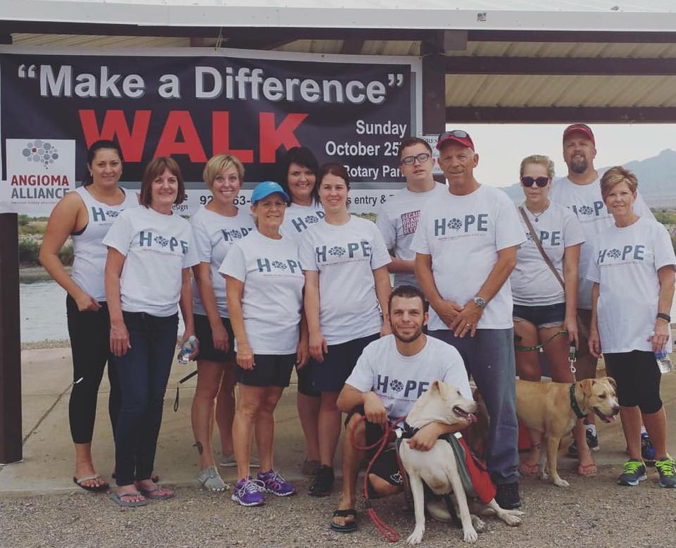

Car Wash: It’s a time-tested method that is always a blast – have a car wash! Pick a day that your team members can devote a few hours of their time to washing cars for a suggested donation. Be sure to promote the car wash a few days in advance on your team member’s social media accounts and get together the night before to create signs to hold up and lure passing cars in!

Pizza Lunch/Ice Cream Social: Plan a pizza lunch at your office or school where a local pizza shop donates a few pies and then you sell them for a few dollars a slice. You can top off the lunch with an ice cream social as well! Invite your executives or Principal to scoop and serve the ice cream to employees or students who make a donation.

Day-of Fundraising
- Raffles – Most walks offer raffle items as an additional income source. Common items include beauty gift baskets, gift cards, restaurant gift certificates, experiences, hotel stays, golf foursomes, etc. Attendees can divide their tickets between items by placing them in a basket or cup in front of each item. Depending on the quality of raffle items you can sell them for 1 for $5 or 3 for $10, an arms length for $20 and a wingspan for $50. You will be surprised how many people buy a wingspan! You will need: raffle tickets that can be purchased from an office supply store, a table for items, baskets for tickets.

- Silent auction - donated items can be auctioned off in a silent auction. Common items include beauty gift baskets, gift cards, restaurant gift certificates, experiences, hotel stays, golf foursomes, etc. If you have one or more big ticket items like a vacation condo or airline tickets you will want to silent auction or live auction it to create even more excitement! It’s good to set a minimum bid amount and reasonable bid increments. Contact salband@angioma.org for a sample bid sheet. Auction items can be solicited from friends and family as well as businesses. You will need: a table for auction items, bid sheets, and a helper to pull the sheets and process the winners.

- Food sales – water should be provided for free, but other pre-packaged items can be sold – soft drinks, bags of chips, granola bars, and yogurt are popular options. Some organizations will partner with charities to provide food and beverage (Kiwanis, Fired Up to Help). If you are selling your own food and beverage, please check with your local Department of Health for regulations. What you will need: water, pre-packaged food, a way to dispose of wrappers, a place to stage the food (a table?), and, optionally, an organization that will prepare and sell food on your behalf.

- Charge for day-of activities – for example, face-painting, cake walk, and a bounce house for kids. It’s possible to offer simple activities or competitions (with prizes) during your event and charge for participation. Sample activities include face painting, temporary tattoos, arts & crafts, and balloon animals. Competitions can include carnival games, a cake walk, and depending on the venue, a sports competition like putting or basketball baskets. Prizes can be gift cards (optimally, donated) or, for children, tickets that can be cashed in for small toys. What you will need: talented helpers to solicit prizes and run the activities, prizes, and activities.
Vendors can be hired (at a discount, underwritten or donated) for larger activities like bounce houses, climbing walls, laser tag, or virtual discos. Please make sure your vendor carries insurance if there is a potential for injury. You will need to judge whether the added expense can be recouped through charges for participating in the activities. With these activities, your event can be advertised as a Family Fun Day and may draw a larger crowd. It is best to sell tickets for these activities at the registration table so vendors don’t need to handle cash. Vendors typically provide their own source of electricity, but be prepared for the noise of a generator. What you will need: vendors with liability insurance and a generator, space for the activities, additional advertising to reflect what you offer.
- Pre-event mingling with potential larger donors – a special breakfast, dinner, or cocktail hour where you have an opportunity to explain the work of Angioma Alliance in more detail to those who can help us most. Find a venue where you can hold the event, the venue should be someplace enticing, a beautiful home, an office building with a view, a golf course, etc. The venue should be donated and it is best to have light refreshments (donated) as well. Invite potential large donors well in advance and follow up to ensure their attendance. You will want to let them know this event is to “invite a select group of people to learn more about the Angioma Alliance Walk and ask for their support”.

PUBLICITY
It’s never too early to start publicizing your event.
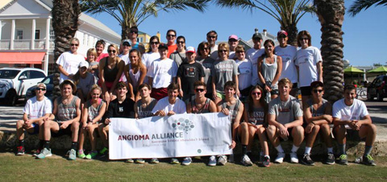

Honoree
An important part of the publicity for an event starts with your honoree. It will most likely be the person you are walking for. Make sure to include their picture and name on the flyer. People are more likely to support you and your honoree if a picture and their story is included on the flyer. An honoree can also be a caregiver, local celebrity, corporate sponsor, neurosurgeon, or an entire family. An ideal honoree will ask lots of their friends and family to attend.

Trademark of Because Brains Shouldn’t Bleed®
We have trademarked our tagline Because Brains Shouldn’t Bleed® because we do not want another group co-opting it. If you use this tagline, please add the ® superscript (in Word, you can Insert-Symbol). Also, it is critical you associate the tagline with Angioma Alliance rather than your event name. Please do not use it as your own tagline without referencing Angioma Alliance each time it is used. For example, if your event is Team Gabriel, please don’t use the tagline. If your event is Team Gabriel for Angioma Alliance, you may use it wherever the complete event name is used.

Open a Facebook Page
A Facebook page for your event is a great way to spread the word. Include pictures of the affected person and details of the event (continue updating these as they are defined). Post regularly to the page – once a day isn’t too much. As the event gets closer, you can post even more than once a day. A picture with a post goes much further than a simple status update. Share everything you post to your personal Facebook timeline to have more impact. Post facts about cavernous angiomas, information about how the illness has affected you or your loved one, pictures of other people with cavernous angiomas along with their stories, or anything you might think would interest and educate. Ask for page “likes” regularly.
When you have a date and place, you can create an Event page on Facebook as well. Make sure you have a link to your registration page (covered in “Registration” below) in the “About” section of your Facebook page and featured prominently on your Facebook Event page. Reach out to salband@angioma.org to have your event shared on the Angioma Alliance Facebook page, too.

Twitter
If you already have a Twitter account with followers, make use of it in the same way you do the Facebook page. If you don’t have a Twitter account, it may not make sense to open a new one because building a follower base takes time. However, you may encourage others you know who already have accounts to tweet your Facebook status updates. Twitter is also a great way to connect with media personalities who will retweet to their followers. You can also ask them to be an emcee.

Newspaper
An easy way to get into a newspaper is to submit to a Community Calendar. Many towns have more than one paper – a large city paper and smaller town, special interest, or advertising papers - and you can submit to all of them. You can also create a press release, making sure to include the personal connection to the event, and submit it to the Health editor and Local editor. Please allow us to read your press release before you send it out to check for accuracy and so we can help you refine it. We have a template for a press release in the Appendix of this guide. It does help to have a connection to the newspaper – check with your friends to see if anyone can help with this.

Radio
We’ve had good success in obtaining radio interviews on local news/talk stations. From a member who successfully obtained media attention: “With radio, it's fine to contact the DJ themselves, and it does help if you have their support. However, they don't have final say or much pull. I found it best to get the station manager or head marketing representative.” There are talking points in the sample press release in the appendix which include information about cavernous angioma and Angioma Alliance.

Television
Our members have been featured on local news programming both in home interviews and in studio interviews. Again, from a member: “I've found the best way to gain TV attention is to go directly to the anchors. I wrote a request to each of them. I went after the ones who cover health, wellness, or community events. I set meetings with all the major news stations to pitch our story to them.”
Make sure everyone who talks with media has a similar message. You can use the sample talking points document in the Appendix of this guide. Each person should be able to tell:
- The highlights of the affected person’s illness
- How their symptoms and experiences compare to others with the illness
- What the future possibilities are
- How money raised will be used
- Use the sample talking points in the Appendix as a guide.

Online
From a member: “Go to every community event page at every radio, news, and printed press website. Submit a standard press release 8-12 weeks in advance so they have time for the approval process.” Please see the Newspaper section about for information about press releases.
Our members have also advertised their walks on websites for runners. While we’ve never invested in time-keeping equipment (tags on shoes, etc), some runners may turn out on a weekend where no official race is scheduled. If you believe this is possible, please make sure you have 5K measured and marked. Have a volunteer walk the course with a personal fitness device like a Fitbit or Jawbone to track distance.

Schools, Churches, and Workplaces
Don’t forget to spread the word in places where you have connections. It’s easy to ask for a flyer distribution or an announcement in a newsletter.

REGISTRATION

Online with Crowdrise
Once you have determined the date, time and venue of your walk, we can set up your event page on Crowdrise. Crowdrise is our fundraising platform. Individuals can go to this link, register for the event, donate and create their own fundraising webpage. Please reach out to salband@angioma.org to receive an event link.
You can charge a registration fee or the preferred method is to not charge a registration fee with the expectation that individuals will fundraise on their page. If you wish to charge a registration fee the event registration is processed through Eventbrite (but this is a seamless process that works well with Crowdrise). We can discuss this with you to come up with a plan for your event. You will be notified every time someone registers and you can get a complete list of registrants in Excel format from us. T-shirts can also be used as a fundraising incentive.

Registration Events
A number of members have held registration events leading up to their official walk. This can be as simple as announcing where you will be for two hours on a week night, Saturday or Sunday: “Come see us at Eliot’s Coffeehouse on Wednesday from 6-8 pm. We’ll be at the round table registering walkers.” Offer an incentive: “Free tall coffee to anyone who registers.” Or a discount: “Bring a friend and take 20% off registration.”
Some chain restaurants have charity nights during which they donate a percent of sales if a customer mentions the charity of the night. Sometimes, donation can be anywhere from 10-50%. Alternately, if you know the owner of a local restaurant, you may also be able to host a charity night. Your friends eat, and they might as well support you when they do. Combine this kind of fundraiser with a registration night for a larger impact.
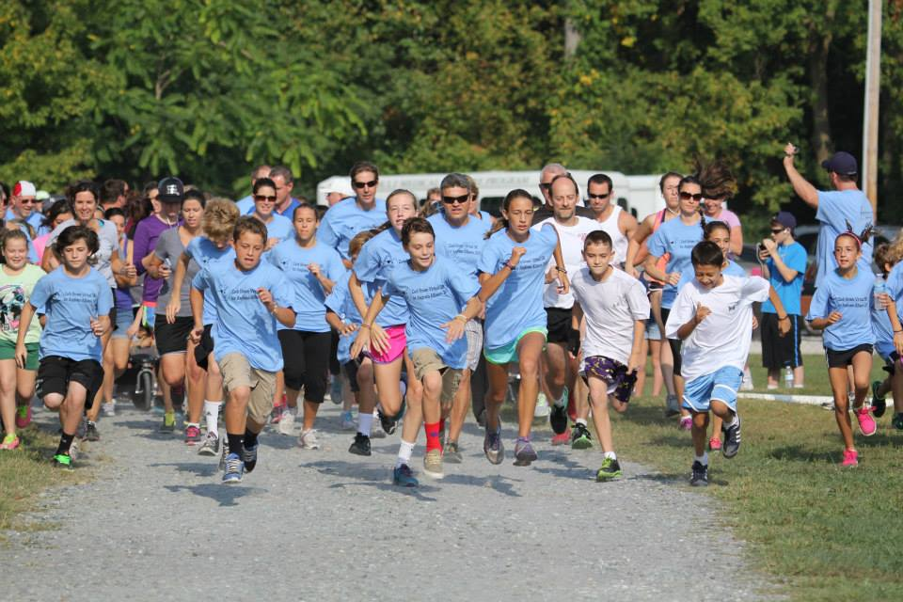
If you are in a venue with wireless or you have a mobile hotspot, you can make a laptop available for online registration. If you don’t have internet access, have registration forms handy (we can provide you with an offline form). Registration fees can be paid with check or cash. You can also collect cash and gift-in-kind donations at an event.

INCOME

Online Fundraising
Angioma Alliance uses Crowdrise to collect online donations and fundraise. Please make it clear on your page that donations will be going to Angioma Alliance and not for your personal medical expenses. To setup a fundraising webpage go to your personalized event webpage. Crowdrise will guide you through the process. You will be asked to sign up with either your Facebook account or your email address. You can join a team already participating, create a new team or participate and fundraise as an individual. From here, you will be prompted through a process of creating an account, setting up a page and adding fundraising and volunteering goals. You will receive a unique link to your fundraising page. Promote the link far and wide. We can help walk you through this if you like.

Checks and Cash
Donors should write checks to “Angioma Alliance.” If you collect cash, you will want to record the name and address of the donor and send it to us within two weeks so a tax receipt can be mailed in a timely manner. Please turn cash donations into a cashier’s check or money order before mailing. Please do not hang onto checks and cash. You can mail donations to us as frequently as you like. We encourage you to keep a running record of the proceeds of your event. You will need a cash box, a helper who can track donations, and envelopes/stamps to mail checks.
One of the best times to solicit donations is during a pre-event gathering for potential larger donors. Consider organizing a cocktail hour, dinner, or breakfast that includes a select group of prominent community members, business people, and philanthropists, particularly if they are known by committee members. This is your time to explain Angioma Alliance and the need. Audio visual aids can help and Angioma Alliance can provide patient pictures as well as facts that you can use to create your own slide show. You will need venue for a pre-event (possibly a larger house with a television and DVD player), invitations, a helper to create a slide show and burn it to DVD, and food/beverages.

Square Credit Card Transactions
A square credit card reader is available for you to use with your tablet or phone before the event and on the day-of. It plugs into your device and you can swipe credit cards or enter the credit card info manually. Please note, the square reader does not capture donor information, only credit card information and the amount. So, you every time you use square you need to capture the donors name, address, email and the last four digits of the card. We can then issue them a tax receipt. Please reach out to salband@angioma.org to have the square sent to you. Please allow a minimum of a week for setup and shipping time.

EXPENSES
As mentioned in the Budget section above, every event has expenses. Please remember that donors, just like you, look at our “cost to raise a dollar” to ensure that the most amount of money is spent on the mission of Angioma Alliance. A general rule to follow is that 25% of your fundraising goal can be spent on expenses.
Angioma Alliance requires that you submit expenses with receipts and invoices. Expenses can be paid at the time they are incurred or at the end of the event.
There are several ways to pay for event expenses:
- You can pay for the expense upfront and submit a receipt to Angioma Alliance for reimbursement. We will send a check to you within a week of receiving your receipt or can reimburse you via PayPal if you prefer.
- For larger expenses, our office can call in a credit card number to the vendor.
- You or a donor can pay for the expense and use it as a gift-in-kind donation to be claimed as a charitable tax deduction. We will need the name and address of the donor, the item donated, and the fair market value of the item (what it would cost to purchase).
- If you have collected cash before the event and you have carefully tracked its source and the amount, you can draw on this cash to pay small expenses like raffle tickets or food for volunteers. Receipts must be submitted for cash expenditures at the end of your event.
There is a form in the Appendix that you may use to list your expenses and submit with your receipts.
Please do not open a bank account for the event or deposit any money from the event into your personal account.
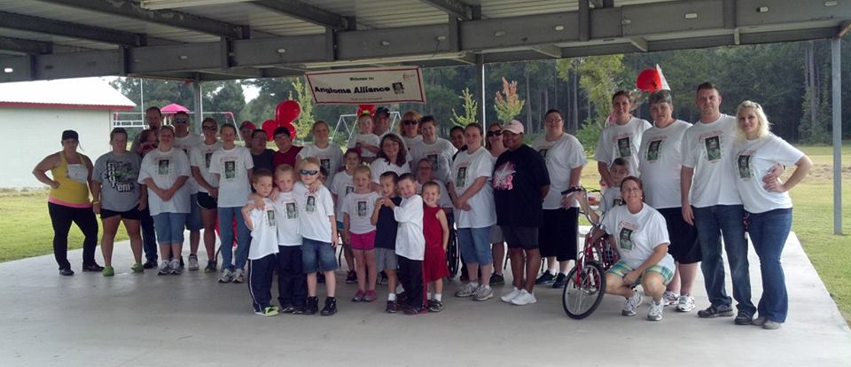

DAY-OF LOGISTICS
The day of the event will be stressful with many things happening at the same time. It’s very important divide among your team and create checklists in advance. Major areas of responsibility could include: Parking, Vendor Set Up, Raffle and Auction, Food, Walk Route, Kid’s Activities and Entertainment, and Clean Up. Each area could have a number of volunteers, if needed. Have a couple of extra leaders designated as floaters who can pinch hit in case a key person is unable to make the event or who can take on unexpected complications.
That said, the most important part of the event is having fun. Small (or large) things may go wrong, but it is likely your participants won’t notice. A sense of humor will go a long way toward saving the day.
Please encourage your attendees to keep participating – egg them on to buy raffle tickets, bid on auction items, participate in activities, and make cash donations. After all of your hard work, you’ll want to get the most out of the event that you can. What You Will Need: Everything on your checklists, a good team, and a sense of humor.

Registration
One of the first areas to setup on the day-of is registration. Setting up the registration area and training volunteers well before registration begins will make the event run more smoothly! Have a pre-event box packed with all of your registration materials is key. The registration table tends to be home-base for the event, so have your box prepared with other items you may not need at registration but for other event needs. What you may need: registration list, pens, cash box, petty cash, signage for registration fees, envelopes to collect team money, paper clips, stapler, first aid kit, heavy duty tape, zip ties, markers, registration forms, signage for raffle and any other day-of fundraisers, permit, proof of insurance, day-of contact numbers, etc.

Angioma Alliance Table
At your walk have a table with information about Angioma Alliance to increase awareness. Flyers can be downloaded here. Make it fun and informative. Consider holding a contest or activity centered around increasing awareness for cavernous angioma.
- Hold a face-painting activity at the Angioma Alliance table.
- Hold a contest where any new Facebook followers at the event are entered into a drawing to win a small prize, maybe a walk shirt.
- Have a scavenger hunt where people at the event are asked to fill in answers about cavernous angioma and the honoree. The winner wins a small prize.
- Include a donation box at the table.
- List facts about cavernous angioma.
- Man the table with a friendly, knowledgeable volunteer.
- Create a flyer/poster with information about the honoree’s journey with cavernous angioma.

Parking Assistance
If you have more than 100 pre-registrations for your event, you may want to consider assistance with parking. This can be as simple as one or more volunteers wearing a reflective orange vests waving people into specific rows in the parking lot. You may need cones to block off full rows. If your venue is a camp or school, you may be able to borrow the facility’s traffic control equipment. If it looks like your parking is going to cause a backup on a road, you will need the help of the local police. When you call the police department, please be sure to mention this is for a benefit walk so they may waive their fee. What you may need: reflective orange vests, traffic cones, police assistance.

Photography
Take plenty of pictures! Angioma Alliance uses event pictures throughout the year as a way to raise awareness and highlight the wonderful things our members are doing. You’ll also want the memories for the affected person who will find this support to be something to hold on to if times become more difficult. Finally, you’ll need pictures for flyers to advertise and show potential sponsors the following year. Get a picture of the start of the walk, any activities, and small group shots. What you’ll need: a designated photographer with a digital camera.

Signs/Banners
You will want people to find your walk and will want the public who may be in the area to know why you are walking. To accomplish this, you may need cardboard signs and holders, similar to what realtors use, at the entrance to the walk and banners at registration tables or above the walk area. Printing vendors who create t-shirts can produce these items as well. What you will need: digital logo for your walk, measurement of banner (a 5’ banner can be enough for a single registration table), the number of signs you’ll need, vendor, a way to attach the banner, transportation for the banner and signage.
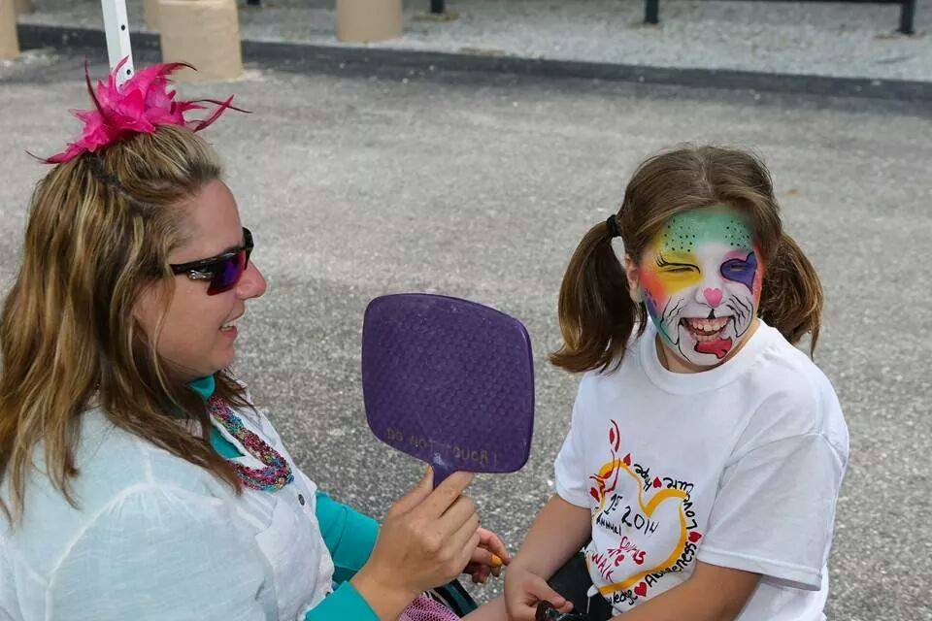

Sound System
It may be necessary to rent or borrow a sound system if the walk area is large and you don’t have a DJ. What you may need: a battery-operated karaoke or PA system with microphone.

Tables and Chairs
If there are no picnic tables at your walk, you will need a registration table at the least. You’ll also need a place for raffle or auction items. If you don’t own a portable table, poll your friends and you are likely to find someone who has a 6’ folding table and folding chairs. You will also want card tables for water stations along the route.

Water Stations
If you have planned a 5K route, your runners and walkers will get thirsty along the way. You can send walkers out with a bottle of water, but it would also be a good idea to have a refill station. Runners will probably not want to carry water and will definitely need water stations. Depending on the size of the walk, a volunteer can stand at the station or you can leave it unmanned with jugs of water, ice in a cooler, and cups. What you will need: table, individual water bottles, water jugs for refills, cups, cooler, and ice.

Volunteer Thank You Gifts
Please make sure you thank your volunteers. Thank you gifts can be homemade, like food or craft items, or they can be purchased like candles or candies. With a heartfelt note, they help your volunteers know how much you appreciate their support. What you will need: gifts and handwritten notes.

AFTER THE EVENT
After the event, there are several tasks remaining:

Account for and Submit Funds
The Appendix in the Guide offers template spreadsheets that you can use to summarize your event. All checks should be made out to Angioma Alliance and you should include the donor’s address if it’s not on the check. All expenses should be accompanied by a receipt. Please turn cash collected into a cashier’s check and let us know the amount of each source of cash – raffle ticket sales, on site registrations, etc. Expenses and income should be sent to Angioma Alliance within two weeks of the event.

Thank Your Volunteers, Sponsors, Donors, and Participants
For large events, you may not be able to thank every donor individually, but you can post to your Facebook page and to your Twitter feed. Personal notes for large donors and sponsors will be appreciated. Angioma Alliance will provide tax receipts for all donations and sponsorships, so this is not something you need to worry about. Finally, gifts for volunteers as mentioned in the Expense section above will help to show your appreciation and encourage participation in your next event. We can also send a special note to donors that need some special attention. Reach out to salband@angioma.org.

Follow-up with Individuals or Businesses Who Offered Future Help
Many times, events will spur ideas or offers, like Angioma Alliance day at a retail business or other opportunities for fundraising. While you don’t need to pick up on these offers immediately, don’t forget about them. Set up a time a few weeks from your event to meet and discuss options.

Write Down What Worked and What Didn’t
At Angioma Alliance, we can use your experience to inform others who are planning events. You’ll also want a record for reference for future events you plan.

Take a Break!
Your event likely has been exhilarating but tiring. It has taken some of your family and personal time. Give yourself as much time as you need to rest and reconnect before beginning your next effort.

THANK YOU!
Thank you for all of the energy and time you and your team put into working toward a cure. Angioma Alliance runs on volunteers like you. Together, we can shorten the time to real treatments dramatically. Your work has given hope to patients and their families everywhere.

APPENDIX: TEMPLATES
This Appendix contains the following templates:
- Venue Solicitation Letter
- Sponsor Solicitation Letter
- Sponsorship Opportunities
- Sponsorship Commitment Form
- In-kind Donation Form
- Friends and Family Letter
- Press Release
- Offline Donation Form
- Expense Summary
- Income Summaries
These are to be used as a guide and can be modified for your walk. Please contact salband@angioma.org for digital versions of these templates and for Angioma Alliance logo files and letterhead.

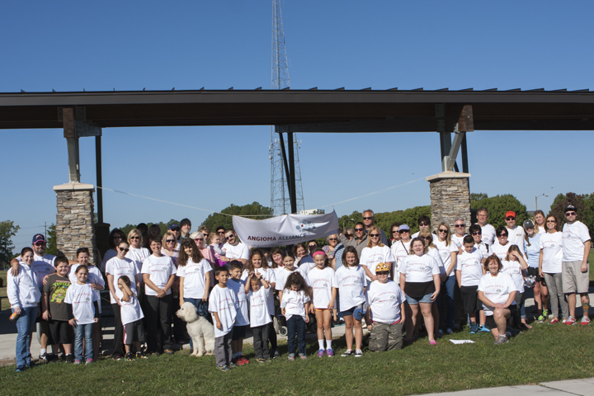

Sample Venue Solicitation Letter
[YOUR NAME]
[PHONE]
[EMAIL]

[VENUE CONTACT AND ADDRESS]

Dear [VENUE CONTACT]:

We are organizing the Angioma Alliance Walk honoring [HONOREE INFO] and are searching for a venue. This fundraiser will benefit the non-profit organization Angioma Alliance, the only patient and research organization supporting those affected by cerebral cavernous angiomas. [HONOREE INFO] Example: Suzi Doe, an Indianapolis 11-year-old, has been diagnosed with this potentially devastating illness, and we are hoping to find real treatments before she is more seriously affected.

A cavernous angioma is a raspberry-shaped abnormal blood vessel in the brain that can hemorrhage and cause strokes and seizures in both children and adults. People with hereditary forms of the illness can develop many cavernous angiomas in a lifetime. Currently, brain surgery is the only treatment. Angioma Alliance is working with researchers to develop medications that will prevent hemorrhage and, for those who have hereditary forms, prevent development of more lesions.

Even at her young age, Suzi has suffered brain bleeding. [MORE OF HER STORY]

Funds from our walk will be used to support Angioma Alliance’s DNA and Tissue bank, a patient registry, an international scientific meeting, and the development of clinical centers of excellence. We are driving research toward a cure! We anticipate [NUMBER] walkers and hope to hold the event on either Saturday, October 5, 201x or Sunday, October 6, 201x. We would appreciate any help you can offer in allowing us to use [VENUE NAME] for the event.

Angioma Alliance is a 501(c)3 non-profit organization. All donations, including gift-in-kind donations, are tax deductible to the extent allowed by law. Our federal EIN is 02-0600697. Angioma Alliance carries full liability insurance ($1 million/occurrence and $500,000 rental property damage) and can provide a Certificate of Insurance for your venue.

Collectively, our efforts result in a nationwide community bound together by Cavernous Angioma, but we don’t let our diagnosis define us - it only empowers us! For more information about cavernous angioma and Angioma Alliance go to www.angioma.org. Thank you for your consideration,

Your Name
Event Organizer

Sample Sponsor Solicitation Letter
[EVENT ORGANIZER NAME]
[PHONE]
[EMAIL]
[SPONSOR CONTACT AND ADDRESS]

Dear [SPONSOR CONTACT]:

We are organizing the Angioma Alliance Walk honoring [HONOREE INFO] to be held on [DATE] at [LOCATION] and would like to offer you the opportunity to become a sponsor. This fundraiser will benefit the non-profit organization Angioma Alliance, the only patient and research organization supporting those affected by cerebral cavernous angiomas. [LOCAL CONNECTION/HONOREE INFO] Ex.: Suzi Doe, an Indianapolis11-year-old, has been diagnosed with this potentially devastating illness, and we are hoping to find real treatments before she is more seriously affected.

A cavernous angioma is a raspberry-shaped abnormal blood vessel in the brain that can hemorrhage and cause strokes and seizures in both children and adults. People with hereditary forms of the illness can develop many cavernous angiomas in a lifetime. Currently, brain surgery is the only treatment. Angioma Alliance is working with researchers to develop medications that will prevent hemorrhage and prevent development of more lesions.

Even at her young age, Suzi has suffered brain bleeding. [MORE OF HER STORY]

Funds from our walk will be used to support Angioma Alliance’s DNA and Tissue bank, a patient registry, an international scientific meeting, and the development of clinical centers of excellence. We are driving research toward a cure! Sponsorship opportunities are listed on the following page.

Angioma Alliance is a 501(c)3 non-profit organization. All donations, including gift-in-kind donations, are tax deductible to the extent allowed by law. Our federal EIN is 02-0600697. Collectively, our efforts result in a nationwide community bound together by cavernous angioma, but we don’t let that define us, it only empowers us! For more information about cavernous angioma and Angioma Alliance go to www.angioma.org.

Thank you for your consideration,

[EVENT ORGANIZER NAME]
Event Organizer
[EVENT ORGANIZER CONTACT INFO]

Sample Sponsorship Opportunities
Angioma Alliance Walk
Honoring [HONOREE NAME]
[EVENT LOCATION]
[EVENT DATE]
[EVENT ORGANIZER]
[PHONE AND EMAIL ADDRESS]

SPONSORSHIP OPPORTUNITIES
Presenting Sponsor - $10,000
- Name and Logo prominently featured on event website, event email blasts, Angioma Alliance webpage, and social media posts
- Logo as Presenting Sponsor on event banner
- Logo printed on walk route signage
- Logo included on event flyer
- Logo featured as Presenting Sponsor on back of participant t-shirts
- 10x20’ premier vendor/exhibit space at event to distribute product and promotional materials
- Sponsor highlighted in all pre- and post-event publicity
- Ten event registrations and ten event t-shirts
Gold Sponsor - $5,000
- Name and Logo featured on event website, event email blasts and social media posts
- Logo as Presenting Sponsor on event banner
- Logo included on event flyer
- Logo featured prominently on back of participant t-shirts
- Vendor/exhibit space at event to distribute product and promotional materials
- Sponsor mentioned in all pre- and post-event publicity
- Five event registrations and five event t-shirts
Silver Sponsor - $2,500
- Name and Logo featured on event website, event emails blasts and social media posts
- Logo as Silver Sponsor on event banner
- Logo included on event flyer
- Logo featured on back of participant t-shirts
- Vendor/exhibit space at event to distribute product and promotional materials
- Five event registrations
Bronze Sponsor - $1,000
- Logo included on event flyer
- Logo featured on back of participant t-shirts
- Two event registrations
Vendor Sponsor – see below
- Vendors may sell items at the walk
- Vendors agree to provide 1 item for the walk silent auction/raffle
- Vendors agree to provide their own table/chairs/canopy

10’ x 20’
_____ $200 - Space without percentage of sales
_____ $150 - Space with 15% of sales donated
_____ $50 - Electricity w/ 2-plug 120V receptacle
10’ x 10’
_____ $150 - Space without percentage of sales
_____ $100 - Space with 15% percent of sales donated
_____ $50 - Electricity w/ 2-plug 120V receptacle

Sample Sponsorship Commitment Form

Angioma Alliance Walk
Honoring [HONOREE NAME]
[EVENT LOCATION]
[EVENT DATE]
[EVENT ORGANIZER]
[PHONE AND EMAIL ADDRESS]

SPONSORSHIP COMMITMENT FORM
Select Sponsorship Level:
_____ PRESENTING SPONSOR $10,000
_____ GOLD SPONSOR $5,000
_____ SILVER SPONSOR $2,500
_____ BRONZE SPONSOR $1,000
_____ VENDOR SPONSOR

10’ x 20’
_____ $200 - Space without percentage of sales
_____ $150 - Space with 15% of sales donated
_____ $50 - Electricity w/ 2-plug 120V receptacle
10’ x 10’
_____ $150 - Space without percentage of sales
_____ $100 - Space with 15% percent of sales donated
_____ $50 - Electricity w/ 2-plug 120V receptacle

SPONSOR INFO:
Sponsor Name______________________________________Contact Person: ____________________________
Phone: __________________________ Email Address: ______________________________________________
Address: _________________________________City/State/Zip: _______________________________________
Please send a digital jpg or png file with your logo to [EVENT ORGANIZER] by [PRINTING/T-SHIRT DEADLINE] to receive full benefits of sponsorship. The event is held rain or shine, therefore no refunds. Vendor space is available one hour before registration opens.
PAYMENT INFO:
____ Check (payable to: Angioma Alliance, sent to address below and received by date of walk).
____ Invoice (Invoice will be sent to address above. Payment must be received by date of walk.)
____ Credit Card
Name on card: _____________________________ Card #: ________ - ________ - ________ - ________
Expiration date: _____ / _____ CCV: _______
Billing Address, City, St., Zip: _____________________________________________________________

Sponsor Signature _____________________________________ Date __________________
SUBMIT COMPLETED FORM TO: [EVENT ORGANIZER] by [PRINTING/T-SHIRT DEADLINE] to receive full benefits of sponsorship.
Angioma Alliance is a 501c3 organization, tax id #02-0600697. Your contribution is tax-deductible to the full extent of the law.

Sample Inkind Donation Form
Angioma Alliance Walk
Honoring [HONOREE NAME]
[EVENT LOCATION]
[EVENT DATE]
[EVENT ORGANIZER]
[PHONE AND EMAIL ADDRESS]

IN-KIND DONATION FORM

In-Kind Donor Information:

Name______________________________________Contact Person: ___________________________________

Phone: __________________________ Email Address: ______________________________________________

Address: _________________________________City/State/Zip: _______________________________________

Number of Donated Items: ________

Fair Market Value of Each Item: $________________________________________________________________

Total Fair Market Value: $________

Item(s) Description:
____________________________________________________________________________________________

____________________________________________________________________________________________

____________________________________________________________________________________________

____________________________________________________________________________________________

Please contact [EVENT ORGANIZER & CONTACT INFO] by [DEADLINE] to arrange pick up/drop off of your item.

Angioma Alliance is a 501c3 organization, tax id #02-0600697. Your contribution is tax-deductible to the full extent of the law.

Sample Friends and Family Letter
[EVENT ORGANIZER NAME]
[PHONE]
[EMAIL]

Hi Friend!

On [DATE] we are organizing the Angioma Alliance Walk honoring [HONOREE INFO] to be held at [LOCATION] and I hope you will support my efforts to organize this walk! The event will benefit the non-profit organization Angioma Alliance, the only patient and research organization supporting those affected by cerebral cavernous angiomas.

I am volunteering to help organize the walk honoring [LOCAL CONNECTION/HONOREE INFO] Ex.: Suzi Doe, an Indianapolis 11-year-old, has been diagnosed with this potentially devastating illness, and we are hoping to find real treatments before she is more seriously affected.

A cavernous angioma is a raspberry-shaped abnormal blood vessel in the brain that can hemorrhage and cause strokes and seizures in both children and adults. People with hereditary forms of the illness can develop many cavernous angiomas in a lifetime. Currently, brain surgery is the only treatment. Angioma Alliance is working with researchers to develop medications that will prevent hemorrhage and prevent development of more lesions.

Even at her young age, Suzi has suffered brain bleeding. [MORE OF HER STORY]

You can support my efforts and people like Suzi in a number of ways:

- Donate to my fundraising webpage at [WEBPAGE LINK]
- Register for the walk and create your own fundraising webpage at [EVENT WEBPAGE]
- Invite your friends and family to join you at the walk
- Join the committee to help raise funds and awareness
- Sponsor or donate inkind to support my efforts

I hope you are able to offer your support in at least one of the above ways!

Funds from our walk will be used to support Angioma Alliance’s DNA and Tissue bank, a patient registry, an international scientific meeting, and the development of clinical centers of excellence. We are driving research toward a cure!

Angioma Alliance is a 501(c)3 non-profit organization. All donations, including gift-in-kind donations, are tax deductible to the extent allowed by law. Our federal EIN is 02-0600697. Collectively, our efforts result in a nationwide community bound together by cavernous angioma, but we don’t let our diagnosis define us - it only empowers us! For more information about cavernous angioma and Angioma Alliance go to www.angioma.org.

Thank you for your consideration,

[EVENT ORGANIZER NAME]
Event Organizer

Sample Press Release
Angioma Alliance
Internet:
[YOUR EMAIL ADDRESS]
Company Information:
National: Angioma Alliance
520 W 21st St STE G2-411
Norfolk, VA 23517
Ph. 757-344-0562
Local: [YOUR CONTACT INFORMATION]
Media Contacts:
[YOUR NAME]
Walk Organizer
[YOUR PHONE NUMBER]
Local Family [WITH CHILD] With Rare Disease Organizing Walk for a Cure
The Angioma Alliance walk honoring [HONOREE INFO] will benefit Angioma Alliance’s research for rare blood vessel disease treatments
For Immediate Release
[CITY/STATE]/[DATE OF NEWS RELEASE] --- [A compelling introduction to your family’s story, for example: Connie and John Lee didn’t know their infant daughter Julia had a rare brain disease until they were handing her to a brain surgeon. When Julia was just four months old, Connie and John noticed their daughter was irritable and cried often. They knew something was wrong when John, bouncing Julia on his knee to soothe her, felt her go limp.
The next morning, Julia was projectile vomiting. She was slipping in and out of consciousness. Julia’s pediatrician urged Connie and John to rush their infant daughter to Norfolk’s Children’s Hospital of the King’s Daughters, where an emergency CT scan revealed a bleeding mass of blood vessels the size of a small orange inside her brain. Surgeons removed the cavernous angioma, but Julia was left partially paralyzed on her right side. Months of rehabilitation followed. Julia, now six, has had three more brain surgeries to remove hemorrhaging cavernous angiomas and her brain has ten more lesions that could hemorrhage at any time.]
Julia is one of about 6000 children [if an adult is affected, use 25,000] in the United States with an active form of this life-changing illness. On October 5th, she and her family will gather friends and supporters to walk 3 miles to raise money for research. Right now, brain surgery is the only treatment for Julia and children like her. The Lee family would like to see medications to prevent brain hemorrhage.
The Lee family walk, which they have named “Julia’s Walk for a Future” will benefit Angioma Alliance, the national patient advocacy and research organization for cerebral cavernous angiomas, also known as cavernous malformations or CCM. The walk will be held at York River County Park on Saturday, October 5th from 2-4 pm. It will include a variety of children’s activities including face-painting, arts and crafts, a bounce house, and games. Walk registration is $20 per adult. The public is invited.
“Julia’s future is uncertain and we want to know we’re doing everything we can to help her,” says Connie. “Julia has cavernous angiomas in places that are life-threatening or will disable her if they hemorrhage. We are running against the clock.”
About Angioma Alliance
Angioma Alliance is a national patient advocacy and research organization supporting patient and families affected by cerebral cavernous angiomas, also known as cerebral cavernous malformations or CCM. CCM causes the formation of cavernous angiomas - abnormal blood vessels in the brain or spinal cord that resemble mulberries. These can hemorrhage and grow, potentially causing severe neurological deficits, epilepsy, and death. Cavernous angiomas can become active at any age, even in children, and individuals with a hereditary form of the illness can develop over 100 lesions in their brain.
Brain surgery is the only available treatment currently. Angioma Alliance is working with researchers, pharmaceutical companies, and the National Institute of Health to develop medications that can prevent brain hemorrhage and the growth of new lesions. The non-profit organization organizes international scientific meetings, runs a DNA and cavernous angioma tissue bank, has created a patient registry for future drug trials, and has several new initiatives underway to speed the time to treatments.
For more information about cavernous angiomas, visit http://www.Angioma.org.
[IF YOU HAVE A WALK WEBSITE, PLEASE PUT THE PRESS RELEASE ON YOUR SITE AS A WEBPAGE AND AS A PDF FILE. ALSO PROVIDE A LINK TO YOUR WALK OR ANGIOMA ALLIANCE LOGO.]

HTML:
PDF:
LOGO:

CONTACT:
[YOUR NAME]
[YOUR ADDRESS]
[YOUR PHONE]
[YOUR EMAIL ADDRESS]
http://www.angioma.org [OR YOUR WALK WEBSITE]
KEYWORDS: cavernous malformation, cavernous angioma, charity walk, CCM, medical research, rare disease
SOURCE: Angioma Alliance

Offline Donation Form

Please use this form to mail in a donation for a participant or a team. You can also make a donation online at [EVENT WEBPAGE].
I am supporting: _____________________________________________________________________________ (Participant or Team Name)
Who is walking in the: ________________________________________________________________________
(City & State)
DONATION INFORMATION
Name: ____________________________________________________________ Donation Amount: $_________
Address: __________________________________________________________
City: ______________________ State: __________ Zip: _________
Email: ____________________________________________________________
Phone Number: ____________________________________________________

PAYMENT INFORMATION
Payment Type:
Check ______(payable to Angioma Alliance) Cash _____
Credit Card: _____ Credit Card Type: Visa/MasterCard/American Express/Discover
Card Holder Name: ________________________________________________________
Billing Address: __________________________________________________________
City: ______________________ State: __________ Zip: _________
Credit Card Number: ______________________________________________________
Expiration Date: _________________ Security Code: _________ Billing Zip: __________
Card Holder Signature: _____________________________________________________
Thank You For Your Donation!
Please send to [EVENT ORGANIZER & CONTACT INFO].

Angioma Alliance is a 501c3 organization, tax id #02-0600697. Your contribution is tax-deductible to the full extent of the law.

Expense Summary
All expenses must be accompanied by a receipt or invoice. Expenses may be paid using cash collected from walk with proper documentation.
Please note if item was discounted as a donation. Our EIN is 02-0600697.

Vendor | Address (Street, City, State, Zip | Item(s) | Invoice Amount | Discount Percent | Method of Payment

Income Summary

Gift In Kind Worksheet
In order to issue an in-kind donation receipt Angioma Alliance needs the following information.
Name | Company | Street Address | City | State | Zip | Item Donated | Value

Pre-Event Income Worksheet
A spreadsheet capturing cash, checks, and money orders should have the following columns. This includes donations made by vendors and sponsors. It is not necessary to create a spreadsheet for donations through the peer fundraising website.
Name | Street Address | City | State | Zip | Payment Method | Amount

Day-of Income Worksheet
A spreadsheet capturing day-of registration income can have the following columns. It is not necessary to create a spreadsheet for those registered online. We will need to know what items, if any, were included in registration (t-shirt, food, gift bag, etc) and what the value of the items were.
Name | Street Address | City | State | Zip | Number Registered | Payment Method | Amount

Activities/Raffles/Silent Auction Worksheet
The following items can be summarized as a single line on a spreadsheet, with exceptions noted under Raffle ticket sales and Silent Auction Income below.
Source | Cash | Checks
Activity Ticket Sales
Food Sales
Merchandise Sales
Raffle Ticket Sales
Silent Auction Proceeds

Raffle tickets sales - Please note: if you raffle an item with a fair market value of $1000 or over (including 50/50 raffles), we will need the name and address of the raffle winner. They will be issued a 1099 form at the end of the year for tax purposes.
Silent auction income – if someone wins an item by bidding more than fair market value, they are entitled to a tax receipt. In this case, please provide us with the name and address of the winner, the winning item, and how much was bid. All other auction items can be totaled.

